**Day 3: Basic Linux Commands with a Twist**

1. **View the content of a file and display line numbers.**

**Example: cat -n test.txt**



1. **Change the access permissions of files to make them readable, writable, and executable by the owner only.**

**Example: sudo chmod 700 test.txt**

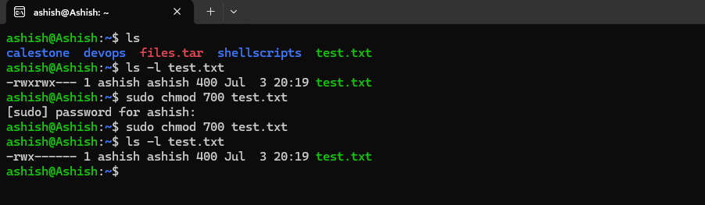

1. **Check the last 10 commands you have run.**

**Example: history | tail -10**

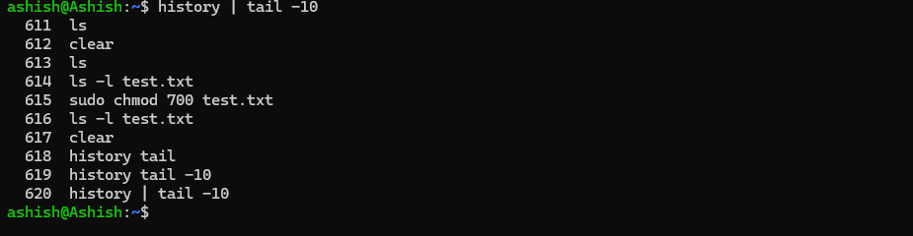

1. **Remove a directory and all its contents.**

**Example: rm -r dev**

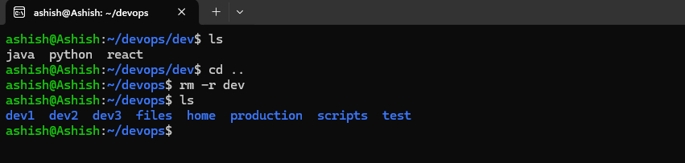

1. **Create a fruits.txt file, add content (one fruit per line), and display the content.**

**Example: run “vim fruits.txt” to create file and the run “cat fruits.txt” to display the contents of the file**

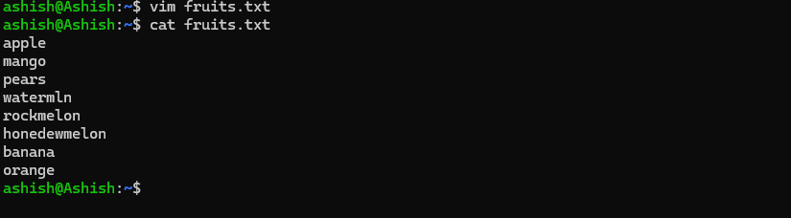

1. **Add content in devops.txt (one in each line) - Apple, Mango, Banana, Cherry, Kiwi, Orange, Guava. Then, append "Pineapple" to the end of the file.**

**Example: We wil use two commands 1st is “echo -e "Apple\nMango\nBanana\nCherry\nKiwi\nOrange\nGuava" > devops.txt” to add contents to devops.txt file and 2nd one is echo "Pineapple" >> devops.txt to append Pineapple to the end of the file**

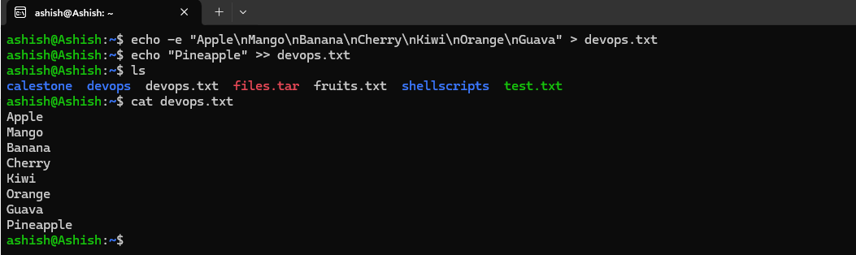

1. **Show the first three fruits from the file in reverse order.**

**Example: head -n 3 devops.txt | tac (Head –n 3 devops.txt will retrieves the last three lines from the file.) (Tac will reverses the order of those lines to display in reverse order)**



1. **Show the bottom three fruits from the file, and then sort them alphabetically.**

**Example: tail -n 3 devops.txt | sort (**tail –n 3 devops.txt will retrieves the last three lines from the file) (sort will display the contents in alphabet order)



1. **Create another file Colors.txt, add content (one color per line), and display the content.**

**Example1: cat >> colors.txt. This command will create a colors.txt file and will prompts to add contents to it. Once you have finished adding contents in press ctrl+d to save the file**

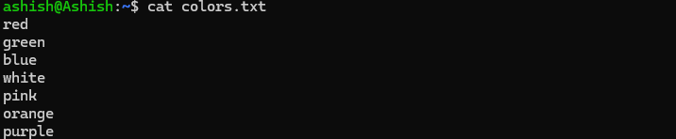

**Example2:** **echo -e "red\ngreen\nblue\nwhite\npink\norange\npurple" > colors.txt**

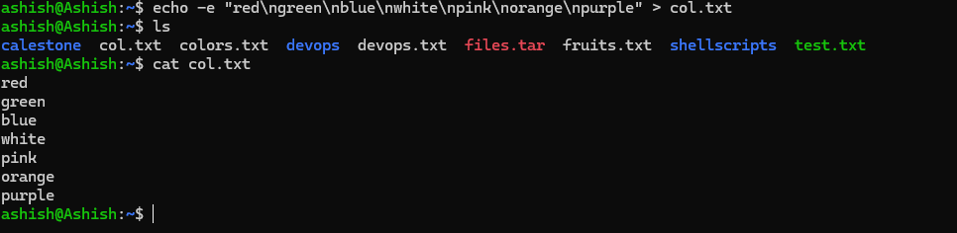

1. **Add content in Colors.txt (one in each line) - Red, Pink, White, Black, Blue, Orange, Purple, Grey. Then, prepend "Yellow" to the beginning of the file.**

**Example: echo -e "yellow\n$(cat colors.txt)" > colors.txt**

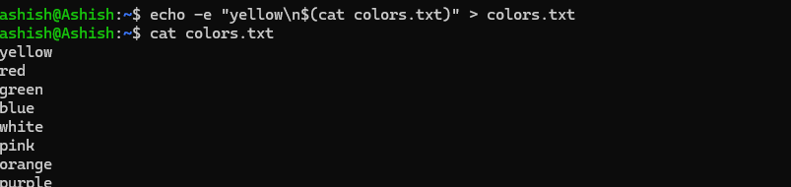

1. **Find and display the lines that are common between fruits.txt and Colors.txt.**

**Example: comm -12 <(sort fruits.txt) <(sort colors.txt)**

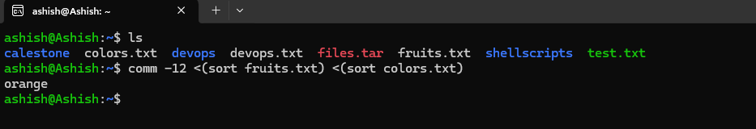

1. **Count the number of lines, words, and characters in both fruits.txt and Colors.txt.**

**Example: wc fruits.txt colors.txt**

